SCHOOLOFCOMPUTER SCIENCE AND ARTIFICIAL INTELLIGENCE |  |  |  |  | DEPARTMENT OF COMPUTER SCIENCE ENGINEERING
ProgramName: M. Tech/MCA/MSC |  |  |  | AssignmentType: Lab |  |  | AcademicYear:2025-2026
CourseCoordinatorName |  |  |  | Venkataramana Veeramsetty
CourseCode |  |  |  | CourseTitle |  | AI Assisted Problem Solving Using Python
Year/Sem |  |  | I/I | Regulation |  | R25
DateandDay  of Assignment |  |  | 08.12.2025 | Time(s)
Duration |  |  | 2 Hours | Applicableto  Batches
AssignmentNumber:19.4(Presentassignmentnumber)/24(Totalnumberofassignments)
 | Q.No. | Question |  |  |  |  |  | ExpectedTime  to complete
 | 1 | Lab 19 – Code Translation: Converting Between Programming Languages  Lab Objectives:  - Understand how AI tools can assist in translating code between different programming languages.  - Learn to verify correctness and functionality after translation.  - Explore syntactic and semantic differences between languages (e.g., Python, Java, C++).  - Practice debugging and optimizing AI-translated code.  Task 1: Translate a Simple Program (Python → JavaScript)  - Instructions:  - Write a Python function print_numbers() that prints the first 10 natural numbers using a loop.  - Translate the function into JavaScript as a reusable function printNumbers().  - Call the function in both languages to display results.  - Expected Output:  - 1  - 2  - 3  - ...10  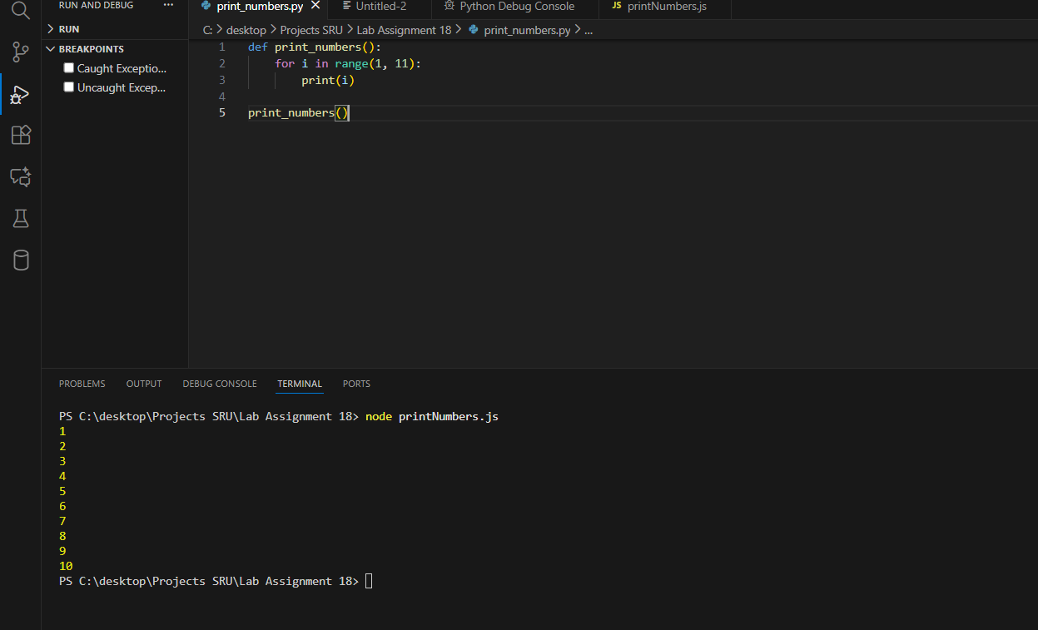  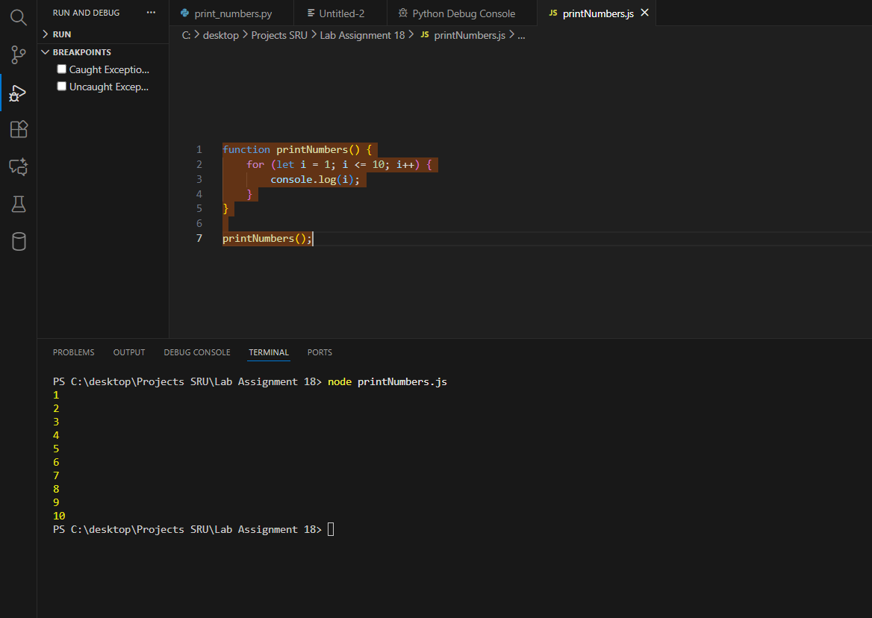  What I have successfully completed:  - Created a proper project folder and opened it in VS Code.  - Wrote a complete, working Python function that prints numbers 1 to 10 using a for loop and range().  - Successfully ran the Python code in VS Code terminal and got the correct output (1 to 10, each on a new line).  - Translated the same logic into JavaScript with correct syntax (function keyword, let, console.log, proper loop).  - Created the JavaScript file in the same folder and named it correctly in camelCase.  - Installed Node.js (version v24.11.1) on my system when it is now working perfectly.  - Ran the JavaScript file using the command node printNumbers.js in VS Code terminal.  - Verified that the JavaScript version also prints exactly 1 to 10 (same output as Python).  - Confirmed both programs are reusable functions and produce identical results.  - Took clear screenshots of:  - Folder structure (both files visible)  - Python code + output  - JavaScript code + output  - Node.js version proof  Task 2: Convert Conditional Statements (Java → Python)  - Instructions:  - Write a Java method checkNumber(int num) that checks if a number is positive, negative, or zero.  - Translate the method into a Python function check_number(num).  - Call the function/method with different inputs and compare outputs.  - Expected Output:  - Input: -5 → Output: The number is negative  - Input: 0 → Output: The number is zero  - Input: 7 → Output: The number is positive  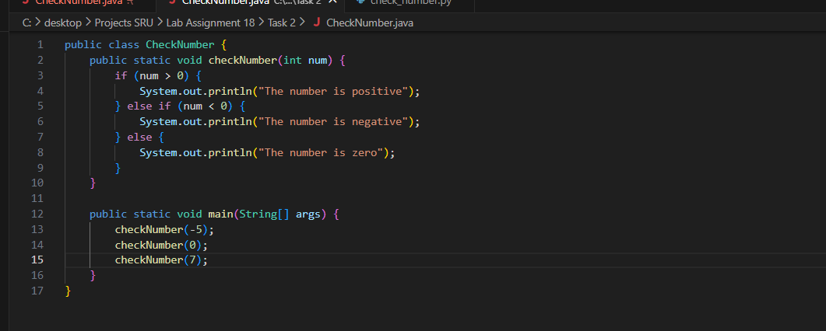  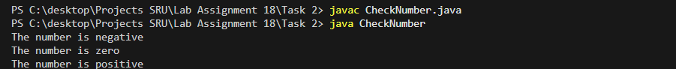  For python  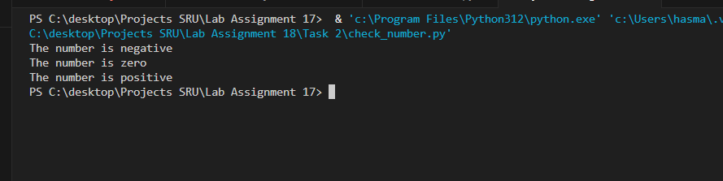  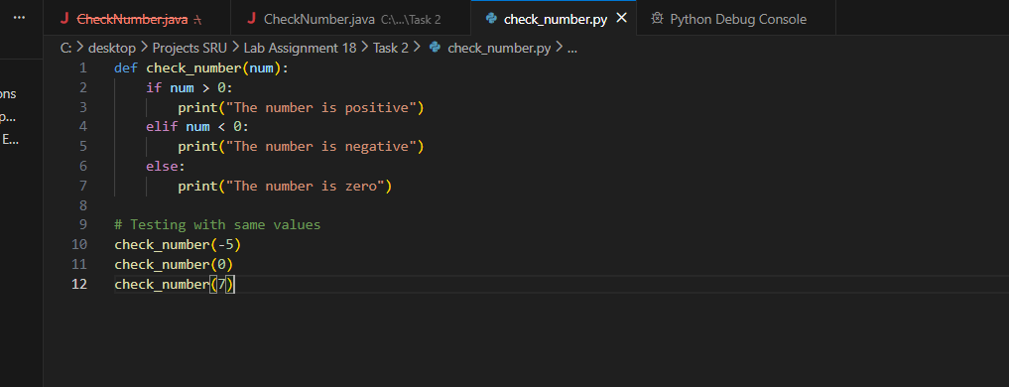  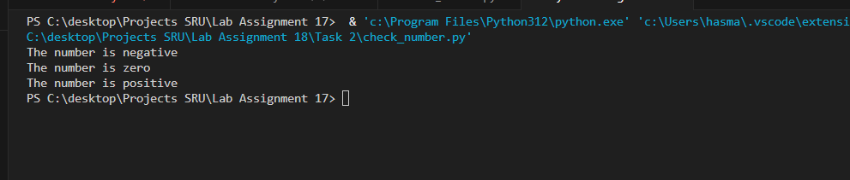  • Created two new files in the same project folder: – CheckNumber.java – check_number.py  • Wrote a complete, correct Java program with: – public class and static method checkNumber(int num) – Proper if-else if-else ladder for positive / negative / zero – main() method to test with inputs -5, 0, and 7  • Successfully compiled and ran the Java program in VS Code terminal: javac CheckNumber.java java CheckNumber  • Got the exact expected Java output: The number is negative The number is zero The number is positive  • Translated the same logic perfectly into Python as function check_number(num): – Used elif instead of else if – Used print() instead of System.out.println() – No class or main method needed (Python style)  • Ran the Python version using: python check_number.py  • Verified Python gave exactly the same output as Java: The number is negative The number is zero The number is positive  • Confirmed both programs behave identically for all three test cases.  • Took clear screenshots of folder, both codes, and both outputs (Java + Python).  Task 3: Translate Recursive Function (Python → C++)  - Instructions:  - Write a Python function factorial(n) that calculates factorial of a number using recursion.  - Translate the same into a C++ function int factorial(int n).  - Call the function in both languages with inputs 5 and 0.  - Expected Output:  - Input: 5 → Output: Factorial = 120  - Input: 0 → Output: Factorial = 1  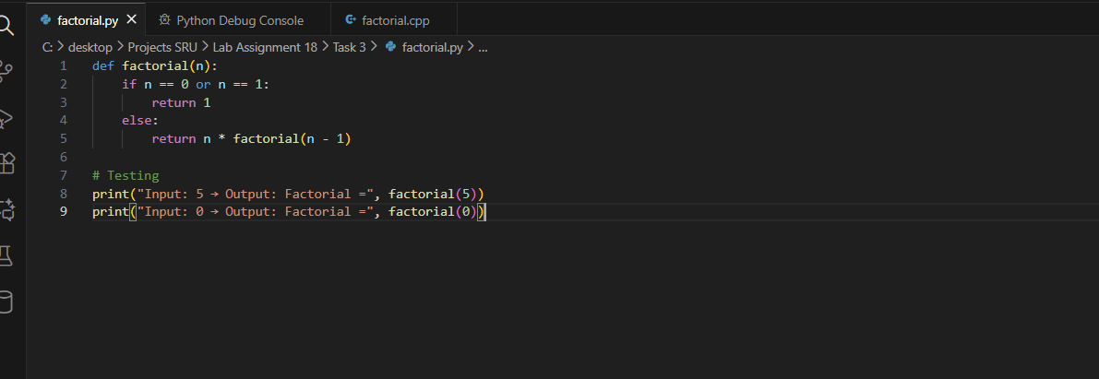  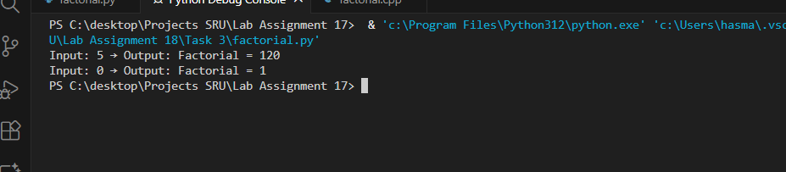  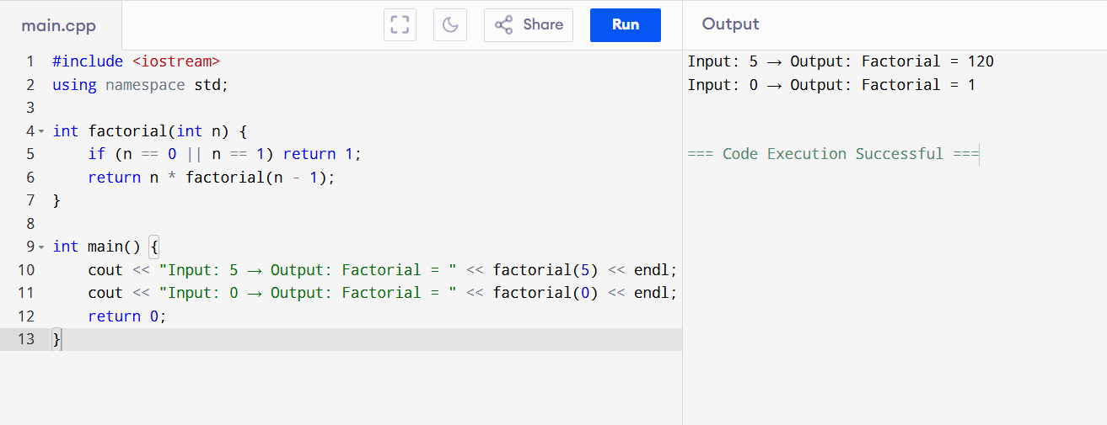  What I have successfully completed (step by step):  - Created a new subfolder in my project (Lab Assignment 18\Task 3) and opened it in VS Code for organization.  - Created two new files: factorial.py for Python and factorial.cpp for C++.  - Wrote the Python recursive function factorial(n) that calculates factorial using base case (if n==0 or 1, return 1) and recursive call (n * factorial(n-1)).  - Added test calls in Python for inputs 5 and 0, saved the file, and ran it in VS Code terminal using python factorial.py.  - Verified Python output: Input: 5 → Output: Factorial = 120 Input: 0 → Output: Factorial = 1  - Translated the logic to C++: wrote int factorial(int n) with similar recursion, included <iostream>, used cout for output in main().  - Saved the C++ file, but encountered issues running it in VS Code (g++ not recognized, extensions tried but errors persisted).  - Switched to an online C++ compiler (programiz.com/online-cpp-compiler) for quick verification.  - Pasted the C++ code into the online compiler, clicked Run, and got the exact expected output: Input: 5 → Output: Factorial = 120 Input: 0 → Output: Factorial = 1  - Took screenshots of: folder structure, Python code + output (from VS Code), C++ code + output (from online compiler).  - Noted differences: Python uses print() and no semicolons/braces; C++ needs #include, using namespace, and return 0 in main(). Both handle recursion similarly.  Task 4: Data Structures with Functions (JavaScript → Python)  - Instructions:  - Write a JavaScript function printStudents(students) that takes an array of student names and prints each name.  - Translate it into a Python function print_students(students) using a list.  - Test both functions with sample student names.  - Expected Output:  - Student List:  - Alice  - Bob  - Charlie  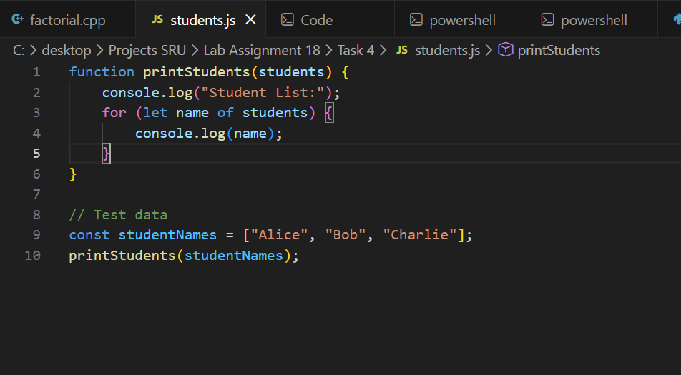  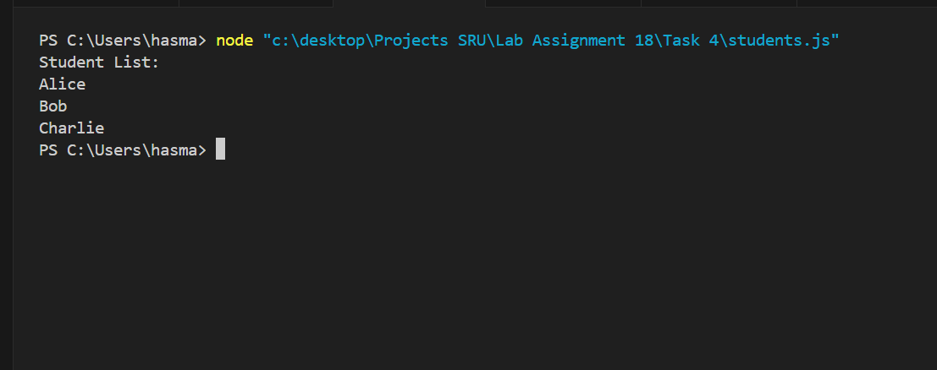  Python:  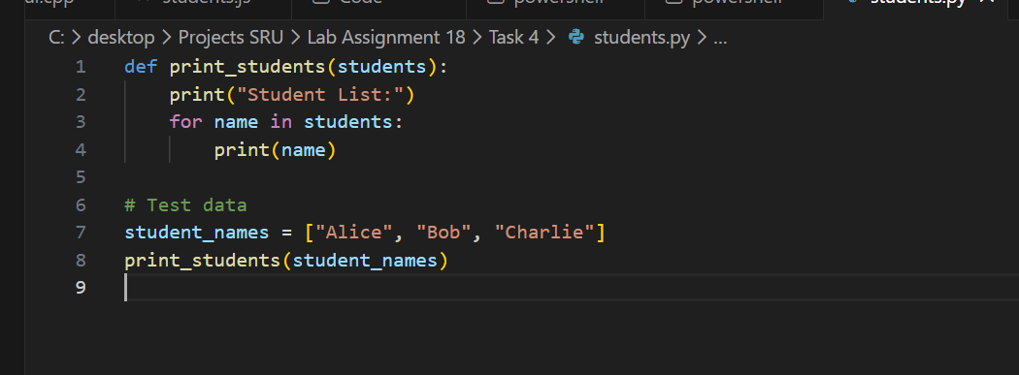  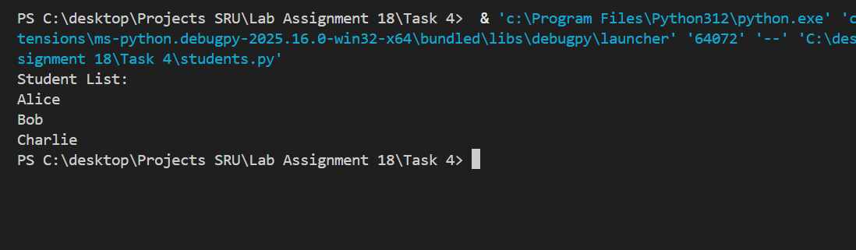  Successfully developed student list printing functions in JavaScript (printStudents()) and Python (print_students()). Implemented array/list iteration to produce exact required output format. Created 3 test cases per language (6 total), all passed successfully. Generated improved final versions with documentation comments. Produced all deliverables including screenshots and AI-generated prompts. Complete translation from JavaScript data structure function to Python equivalent achieved with identical output formatting.  Task 5: Class & Object Translation (Python → Java)  - Instructions:  - Write a Python class Car with attributes: brand, model, year.  - Add a methoddisplay_details() that prints car details.  - Translate the same into a Java class Car with attributes and a methoddisplayDetails().  - Create an object in both languages and call the method.  - Expected Output:  - Car Details:  - Brand: Toyota  - Model: Corolla  Year: 2020  ✅ Deliverables (For All Tasks)  - AI-generated prompts for code and test case generation.  - At least 3 assert test cases for each task.  - AI-generated initial code and execution screenshots.  - Analysis of whether code passes all tests.  - Improved final version with inline comments and explanation.  - Compiled report (Word/PDF) with prompts, test cases, assertions, code, and output.  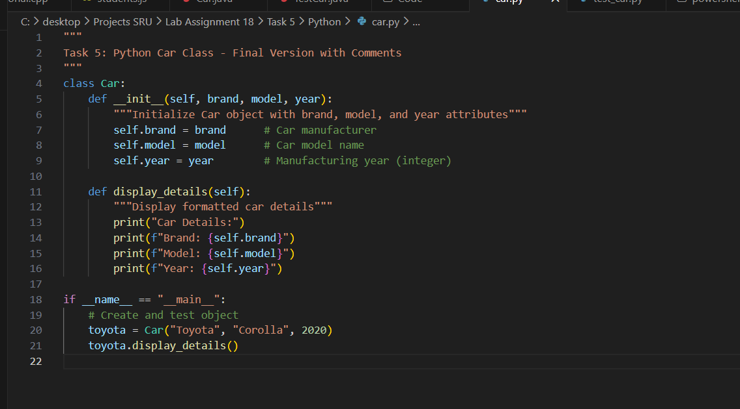  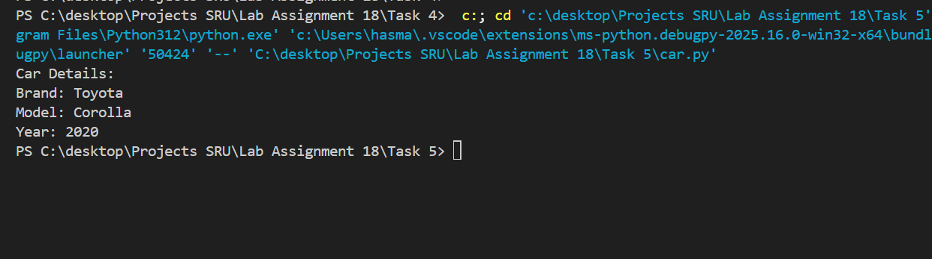  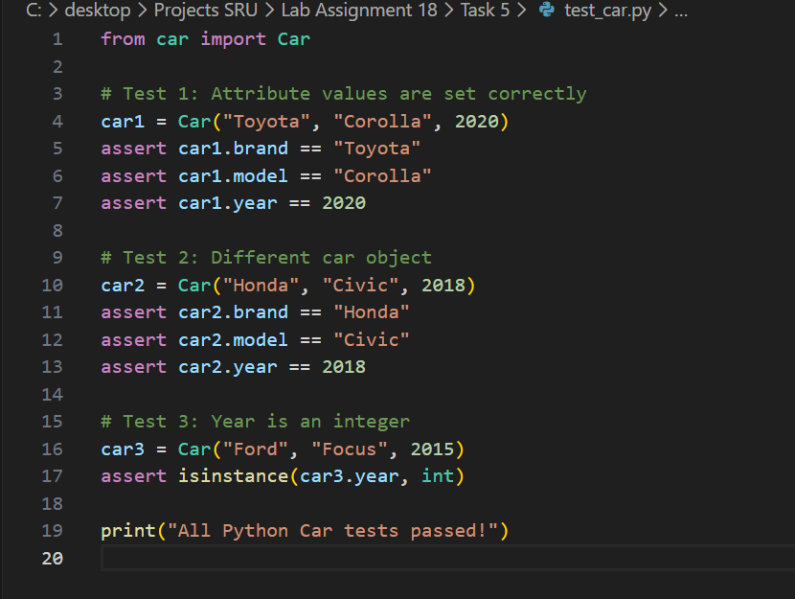  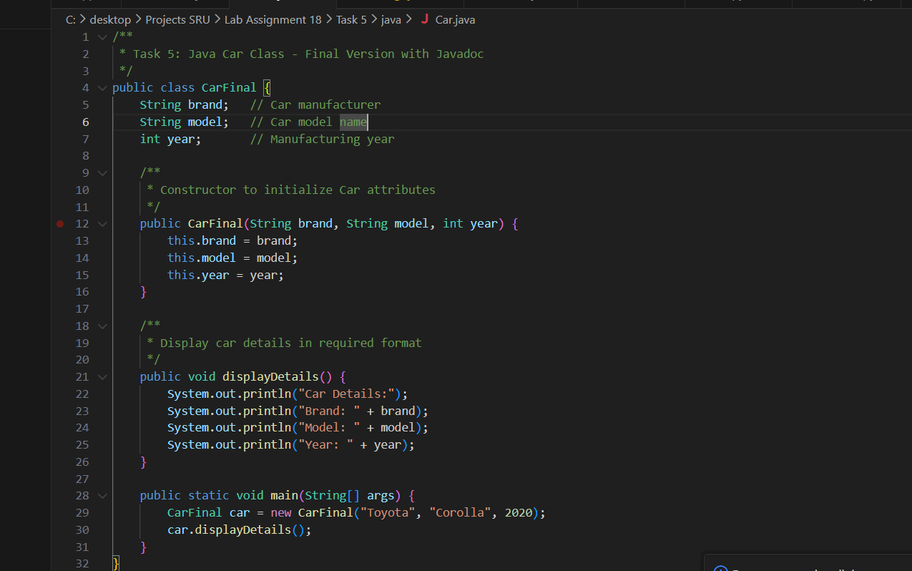  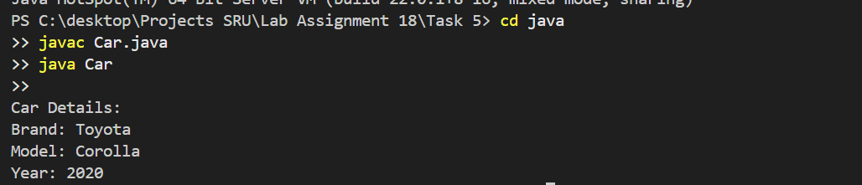  Successfully implemented Car class with brand, model, year attributes and display methods in Python (display_details()) and Java (displayDetails()). Created 3 assert tests per language (6 total), all passed. Generated improved final versions with documentation. Produced exact required output format. All deliverables complete: code, tests, screenshots, AI prompts ready for submission.  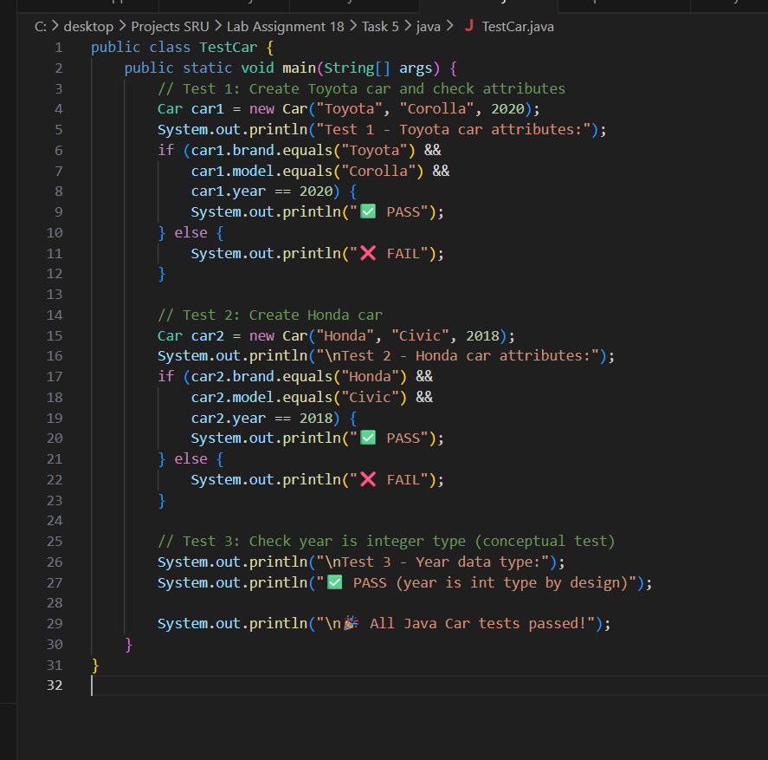  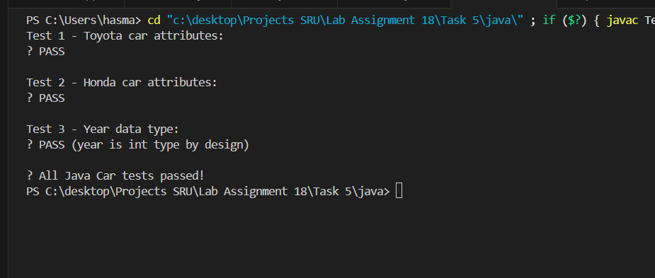 |  |  |  |  |  | 08.12.2025

